

**Deakin University**

LAB ENTRY

Project Handover

Date: 25th MAY 2019

Project Sponsor

DEAKIN UNIVERSITY

Project Team

LAB ENTRY SQUAD-2

Pulkit Mehta, 218069424

Sahithi Uppuluri, 217610793

Krithika Arulselvam, 218019529

Jitender Varma Vejella, 217055372

Bala Chand Tipirneni, 217334617

# Purpose

This document defines the transfer of all relevant information and artefacts produced during the course of SIT782. With this document, a new member should be able to identify all key aspects and artefacts of the project and have access to key systems or configurations.

# Project Description

* All the students enrolled into a SEBE course or unit must complete a mandatory zero-credit safety unit as the minimum requirement before entering a practical lab class.
* The Lab Entry Safety Units are an online unit hosted on D2L (CloudDeakin), with a quiz, which the student must pass to be able to show proficiency in basic lab safety. Each school has a variation (IT – SIT010; LES – SLE010; A&B – SRA010 & SRA710; Eng – SEJ010 & SEE700)
* The current methods are impractical and time-consuming such as presenting printed out certificate as evidence of unit completion, or checking names against a class list.
* Due to these problems there should be a method of checking if the student has completed the required safety unit in either the current or previous trimester – as they enter the lab.
* The vision of this project is to develop a Web Application that can be used to check that students entering labs have completed the required safety unit.
* There are no current web applications that perform the lab entry check hence by undertaking this project; we would be developing a successful one.

# Artefacts List

|  |  |  |  |
| --- | --- | --- | --- |
| **Artefact Name** | **Artefact Type** | **Revision Number** | **Notes** |
| Project Code | Source Code | 25-05-2019 | You can download from Github: |
| Dependencies | Configuration file | 25-05-2019 | Install cloudant, body-parser, express, nodemon packages on your terminal |
| Server | Server access | 25-05-2019 | Setup an express server to run it on local computer |
| Database | Assets | 25-05-2019 | You can find code of the call made to fetch data from Cloudant DB and create similar data on the same platform |
| Images | Assets | 25-05-2019 | You can find them in the images folder on the Github repository |
| Login Credentials | Credentials | 25-05-2019 | Username- admin  Password-admin123  or  Username- tutor  Password-tutor123 |

# Business Features

|  |  |  |  |
| --- | --- | --- | --- |
| **Feature** | **Client Sign-Off State** | **State** | **Notes** |
| Login | 15/4/19 | Final | Tutor can login using his/her login credentials. Credentials are stored on online database(Cloudant) |
| Routing | 15/4/19 | Final | Successful login routes you to the main page |
| Navigation tabs | 20/4/19 | Final | Using bootstrap navigation tabs are added on the main page to view two pages i.e. Unit info and Check ID |
| Data view | 31/4/19 | Final | Viewing of data of students using online database (Cloudant) and HTML table of the main page |
| Import/Export CSV | 4/5/19 | Final | Importing and Exporting of CSV files to view and download the data files |
| Universal Search | 4/5/19 | Final | Universal search to filter data tables on screen |
| Number pad | 15/5/19 | Final | A number pad to enter the student ID |
| Retrieving Response | 15/5/19 | Final | Checking Student ID and retrieving response whether the student has requisite or not |
| Error Messages | 15/5/19 | Final | Toast are used as error messages when check ID requests are made |

# Trello Board:

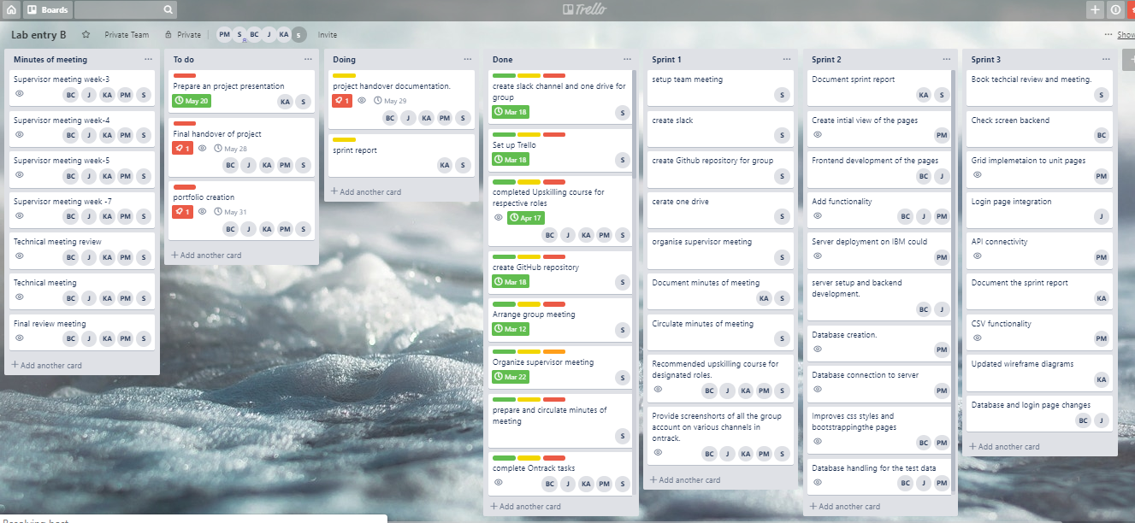

# Planned Work

|  |  |  |  |
| --- | --- | --- | --- |
| **Planned Feature** | **State** | **Sprint** | **Notes** |
| Initial planning and basic design of the website. | Completed | 1 | We formulated a basic plan and design for the website development by creating wireframe diagrams and gathered all the necessary resources related to the project. |
| The website prototype has been developed based on the initial design. | Completed | 2 | The technical development of the project was carried out at this stage. All the frontend (using HTML, CSS, Java Script Bootstrapping, Node JS Server), Database (created in JSON format) and call the functionalities (was done by the Rest API) were established. |
| Final deployment of the web application. | Completed | 3 | The web application with all the necessary functionalities had been developed deployed and handed over. |

Our group each and every task has been planned using the Trello broad indicating the work to be completed with specific deadline along with specific person allocation. Moreover, group members contributions for project tasks are uploaded (commit and pushed) on the team Github repository. We accomplished a successful planning of the project through effective communication on slack channel. All the completed project tasks documents were uploaded on the team one drive providing access to all the team members to view and make necessary correction.

All the work in this project has been planned and completed successfully by regularly attending the technical and supervisor meetings by discussing our project progress and getting feedback for our work. We also got help from them for the technical issues that we faced.

**Open Issues**

The following are the open issues:

* Need API access to fetch university database and will contact the client to give access to that.
* Fetching data from cloud database is a bit slow, can switch to another DB options like Mongo DB, will ask client if they wish to make the requirement changes.

# Lessons Learned

* The ability to meet new people, make a good impression and to communicate to a group.
* The clarity and efficiency of project roles and responsibilities.
* Ability to get the team moving in the same direction towards the common goal.
* Resistance to change in the project scope.
* Researching possibilities, modelling alternatives and making realistic decisions.
* The ability to design visual information.
* Planning the project and managing the implementation.
* The requirements and the quality of deliverables.
* The practice of leading change to overcome resistance to change.
* The effectiveness of problem management.
* Managing time efficiently to improve the quality of the project deliverable.

# High-level architecture of the product

* Project is deployed on the [IBM Cloud](https://www.ibm.com/cloud/). Using cloud foundary services you can access to git repository, database (CLoudant) and IDE
* Project can be easily deployed on the IDE’s editor provided by IBM cloud services
* Project is integrated using Rest web services and has an express js server
* Coding languages used are Html, Node js, JavaScript, Jquery, CSS, Bootstrap and respective scripts are loaded when you run the code
* Data is stored and used in the form of JSON
* Automation testing using [Selenium](https://www.seleniumhq.org/) can be used to test the code

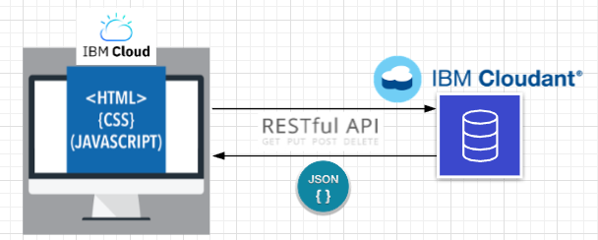

# User Manual

* The address of the webpage is <https://labentry.mybluemix.net/>
* The initial page is the Login page, where the tutor is able to enter the login credentials which will differ to the individual.

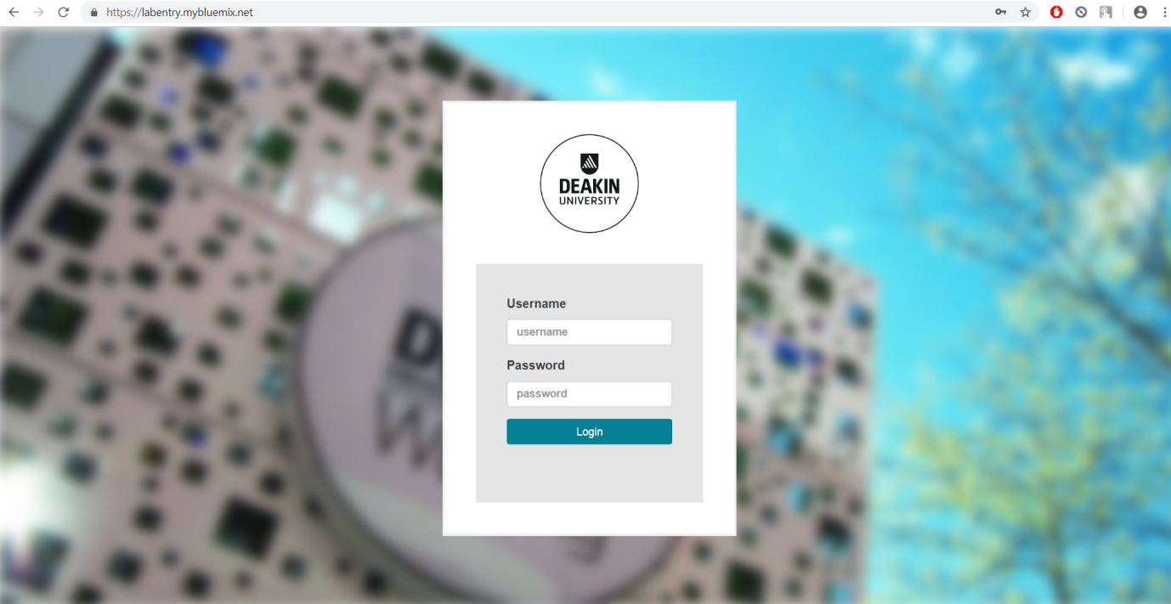

* When the login details were entered, it will go to the database and checks whether the given credentials are stored and also correct or not. If correct, it will connect to the following UNITINFO page.

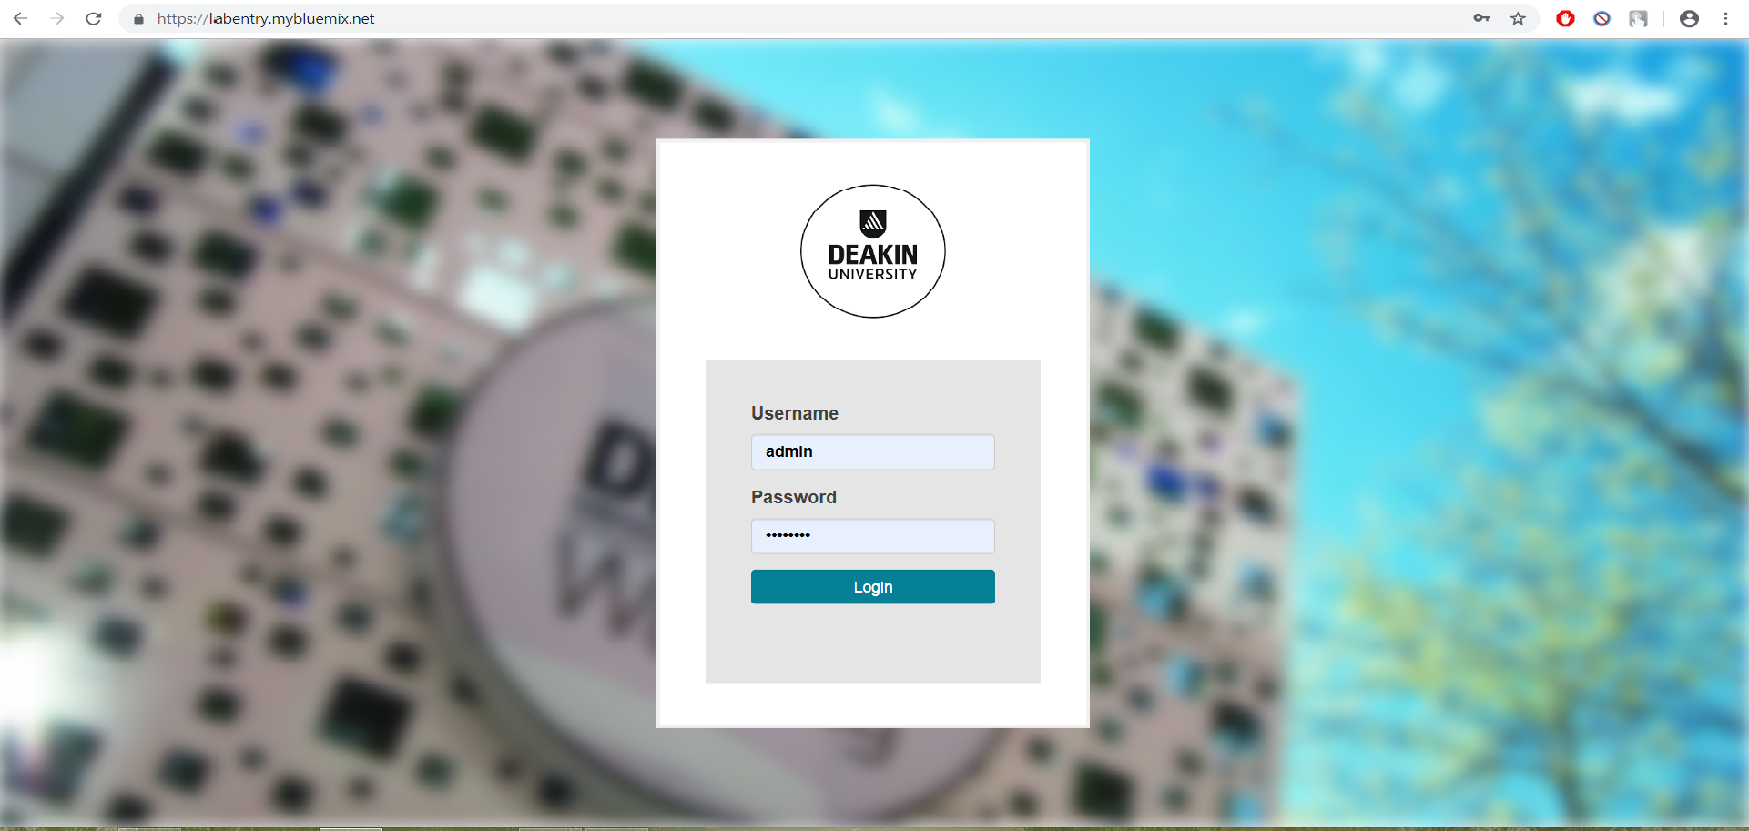

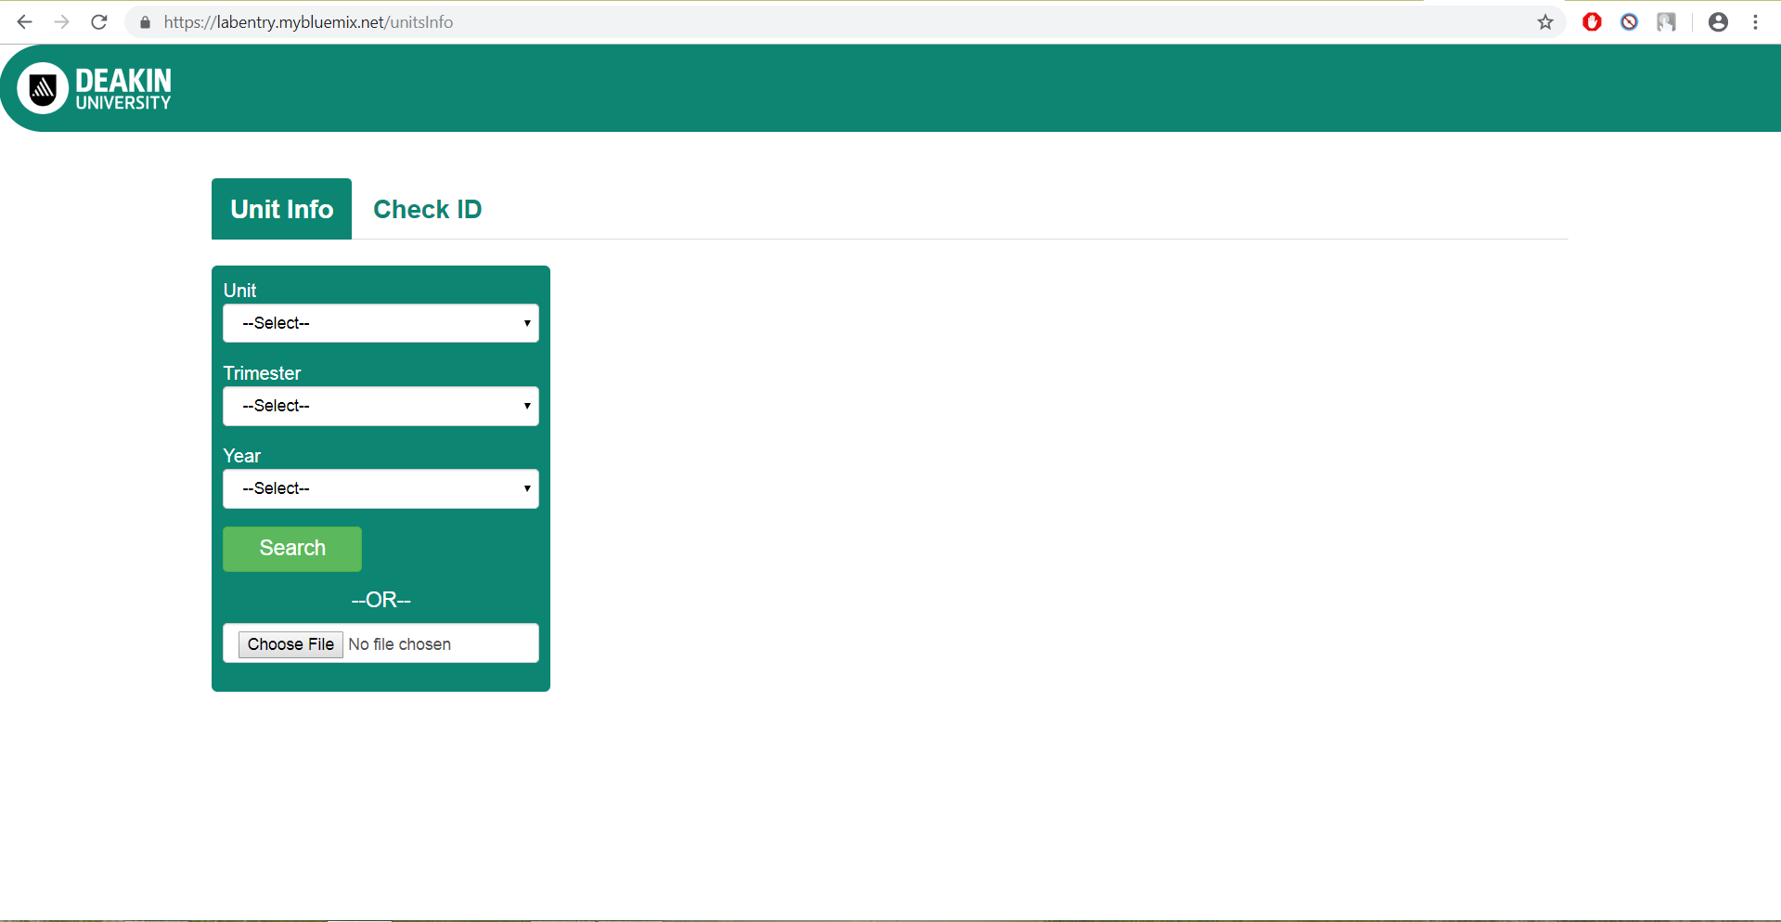

* Or else it will show and error message of the following.

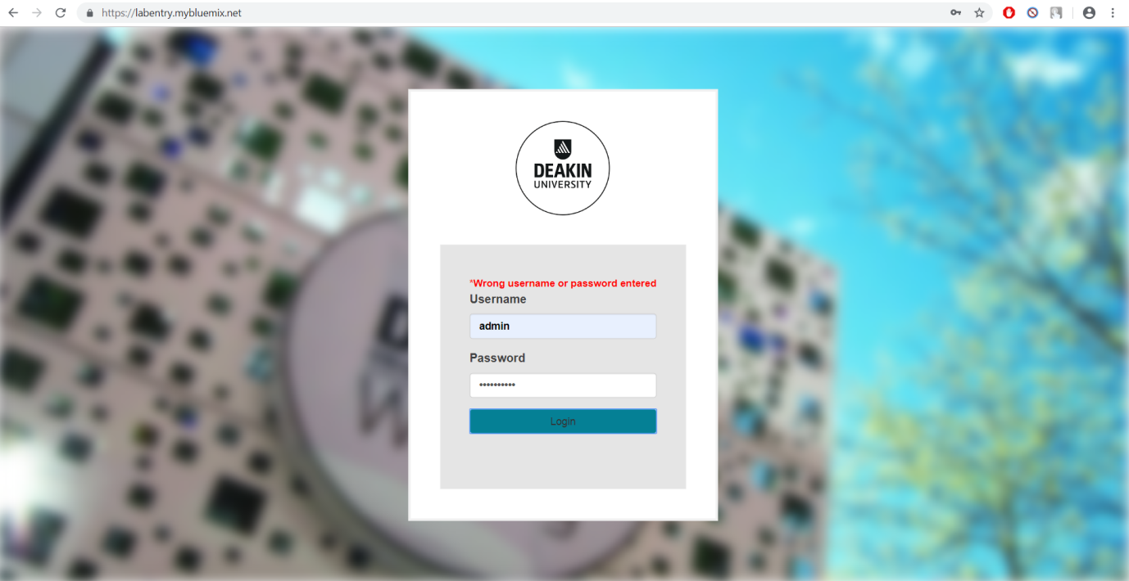

* In UNITINFO page, there are all the Units, Trimester and Year dropdown lists where the tutor is able to narrow the search and able to search accordingly.

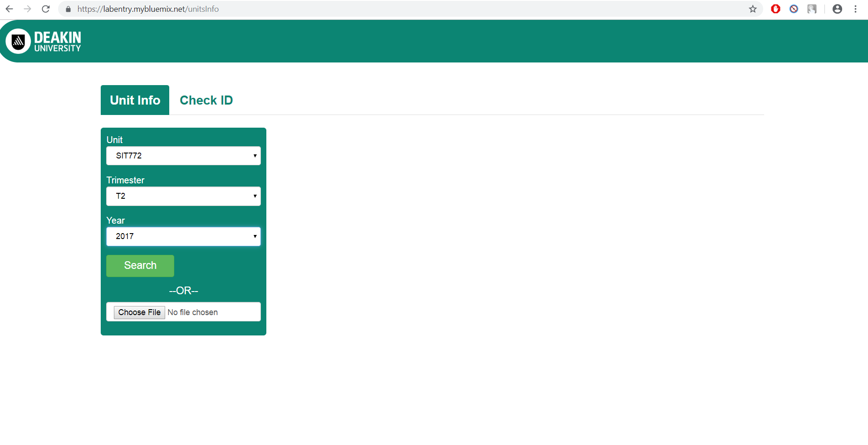

* When the search criterion is made, the function will get the required data from the database and will display in the table.

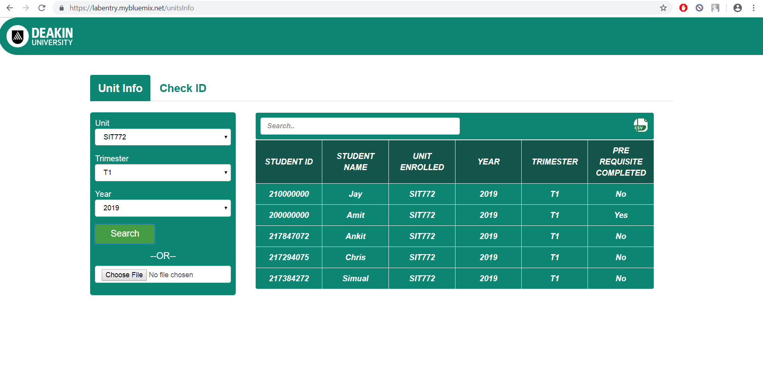

* There is also a grid search bar mentioned at the top of the selected data table, to search for the particular student from that table.

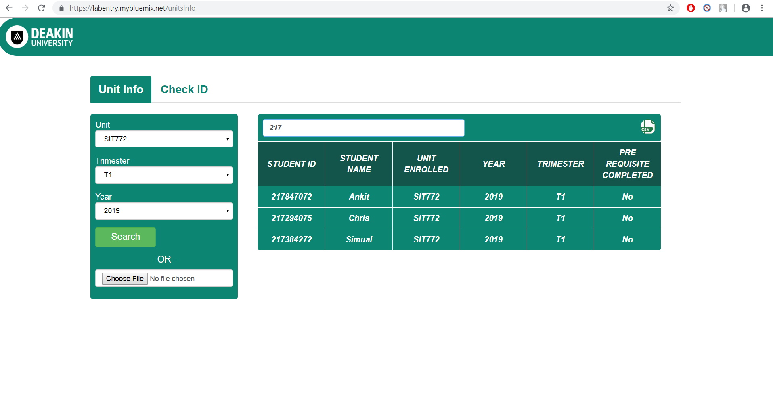

* There is an extra import and export function, where the data from CSV files can be imported and the data from the page can be downloaded as CSV file.

A screenshot of a cell phone

Description generated with very high confidence

* Coming to the CHECK ID page, this will make the search easy in tablet use. This page is made the work simple in tablet kind of devices by using virtual Numeric Keypad.

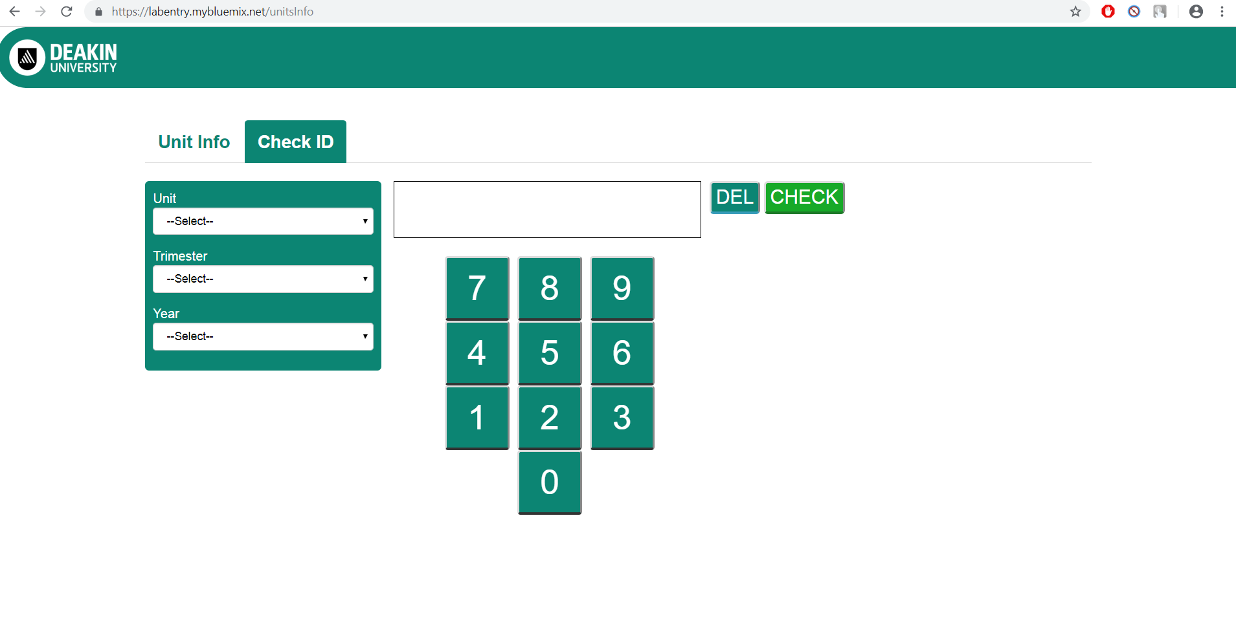

* The search also includes Year, Trimester and Unit details.

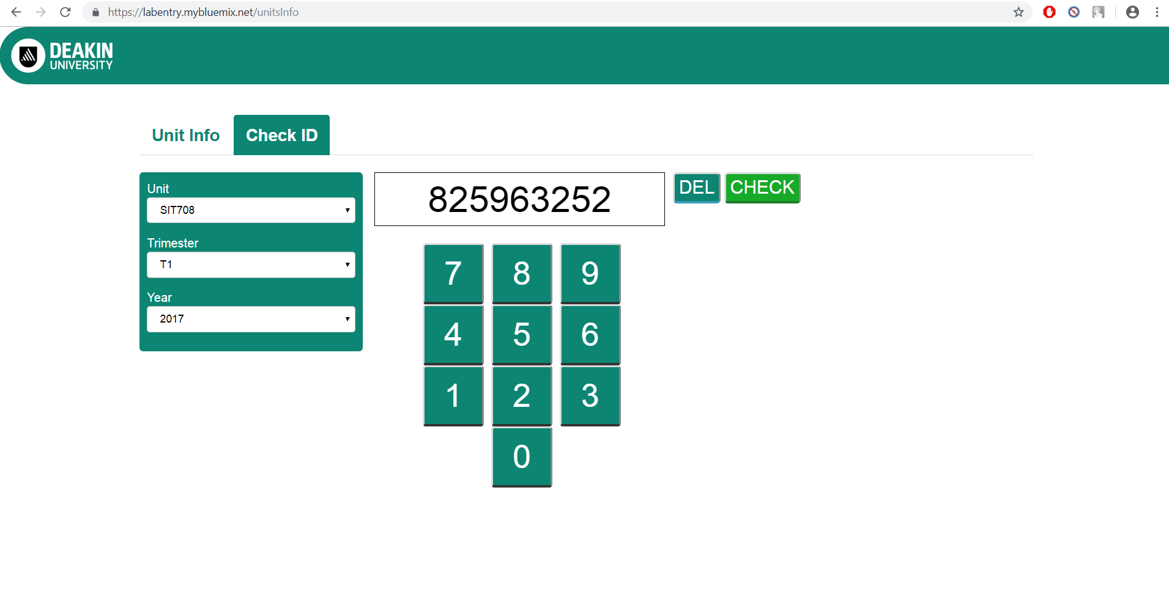

* If the entered details were stored in the database then it will show the results if the student has completed the safety unit or not.

For completed: 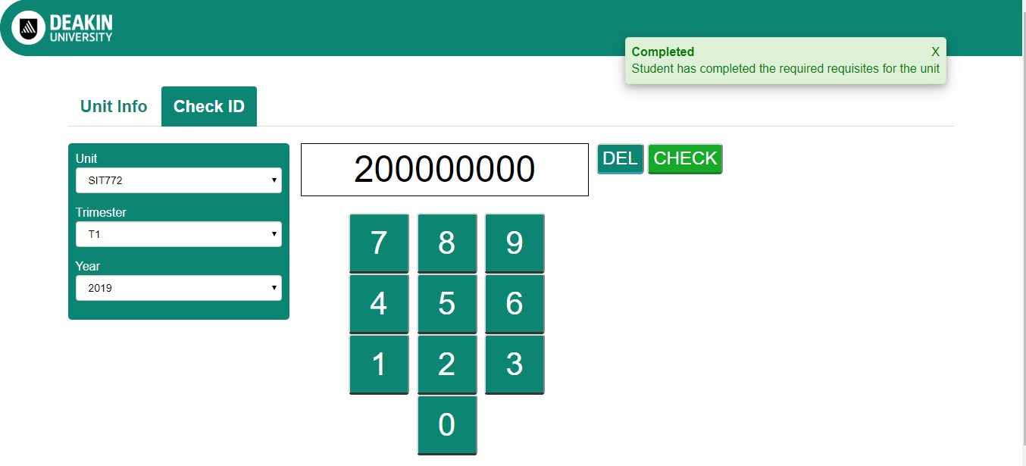

For not completed:

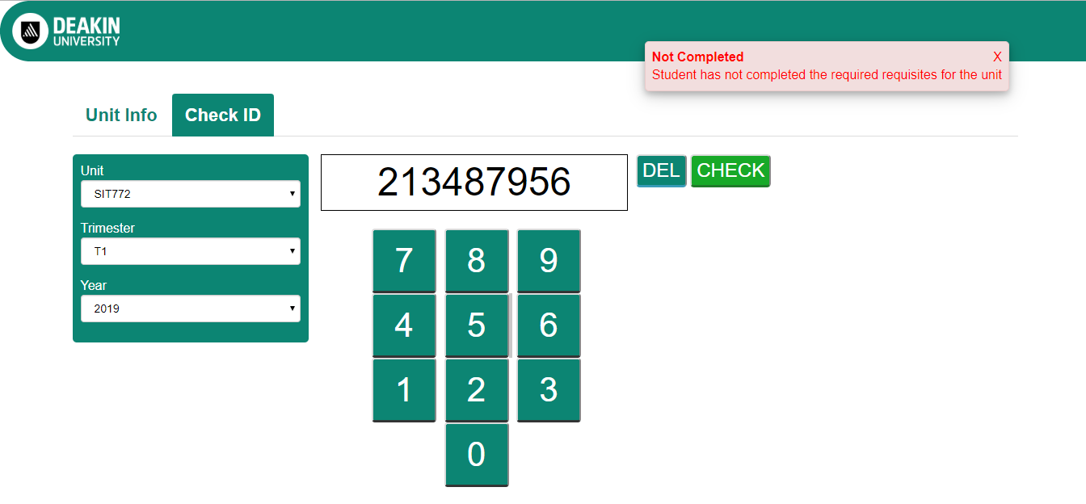

* Or else it will show the error message that NO MATCH FOUND.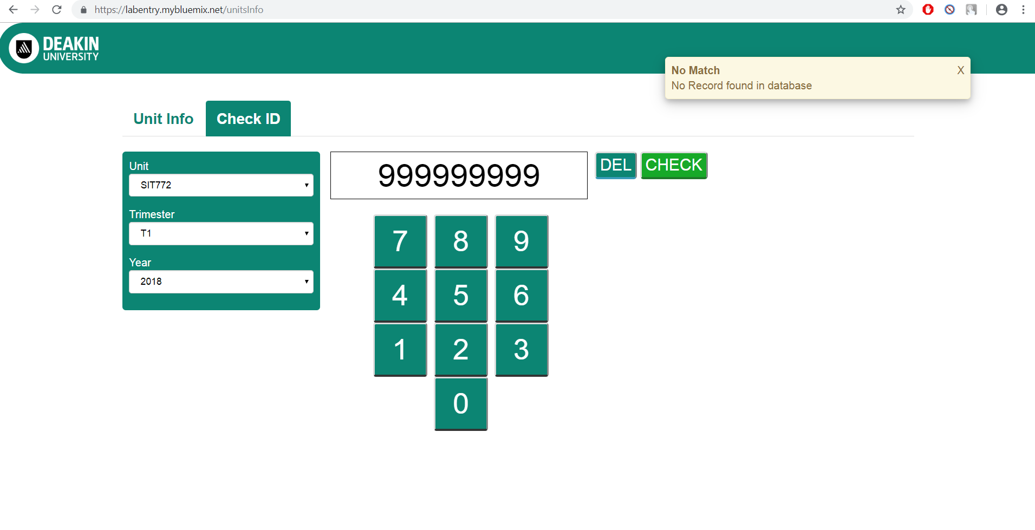

# Sign-off

We **Lab Entry (squad 2) members**, have included all relevant material which is agreed to be included in this handover. If an artefact is not included, it is stipulated in the Planned Work section, or artefacts list.

Date:

22 May 2019

Signed

Pulkit*,* Sahithi, Krithika, Jitender, Bala